* **Node core modules:**

http (launch server/ send request)

https (Launch SSL server)

fs (file system)

path (path to file on different OS)

OS (OS related information).

* **Starting a Server:**

In vanilla node.js application

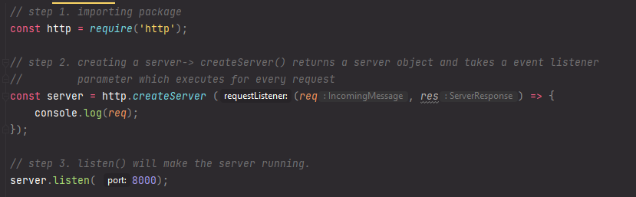

* **Lifecycle:**

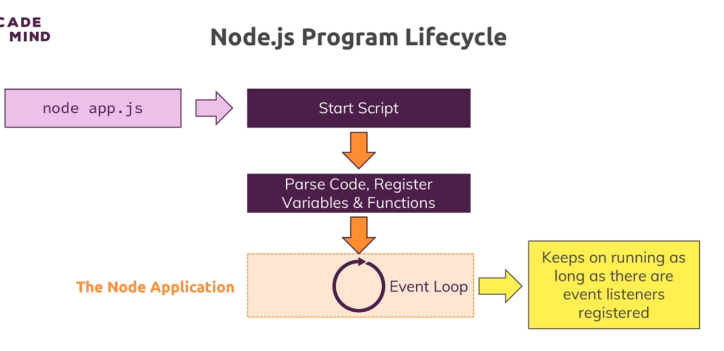

* **Stream and Buffer:** 
  + **Stream**: Here data is sent chunk by chunk instead of sending all at a time. For example- large file, video streaming etc.



* + **Buffer**: Buffer allows us to hold multiple chunks of data. This buffer is then converted into meaningful data.

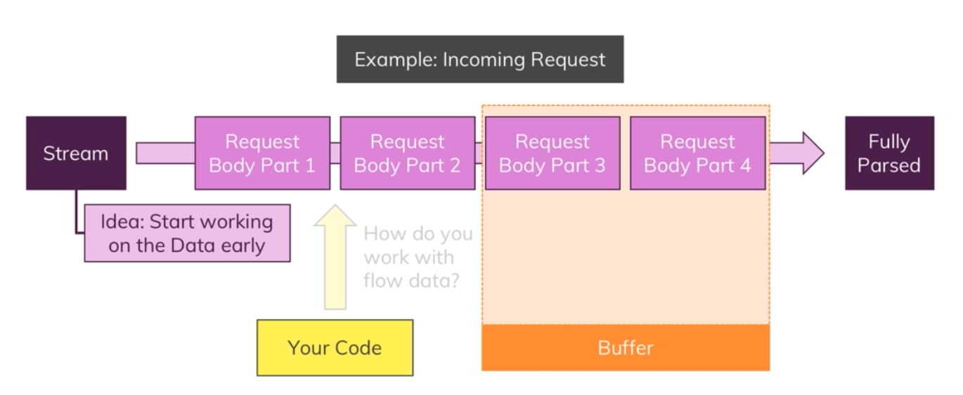

Check the code in the concept folder for details about stream and buffer.

* **Event Driven Code Execution:**

Whenever an event listener (or any asynchronous code) is encountered, node-Js pass this function to the event listener queue. Once the listener fires an event, the callback function will be called.

So, asynchronous functions don’t execute immediately. It waits till the callback function is called and by this time other code executed. This is important point to understand.

